FROM THE BEGINNING

Military Reminiscences of World War II
– as handwritten by Billy J. Burgess

Part III C – Pages 13 -14

“Hardtack” – Jim Hardison & his Crew

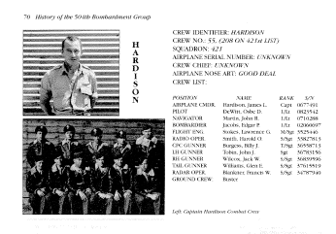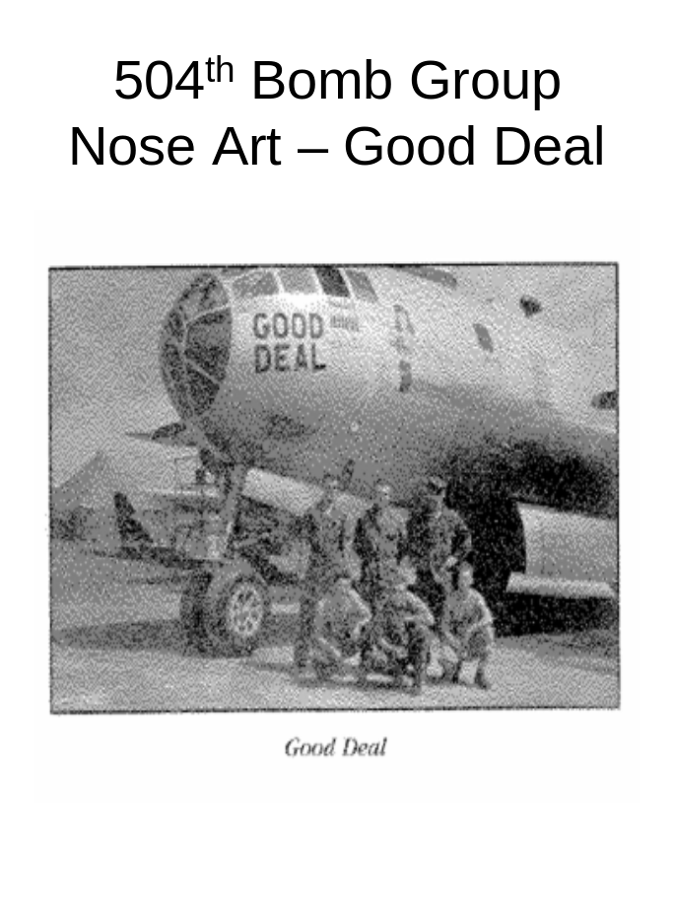
The Crew of B-29 “Good Deal”
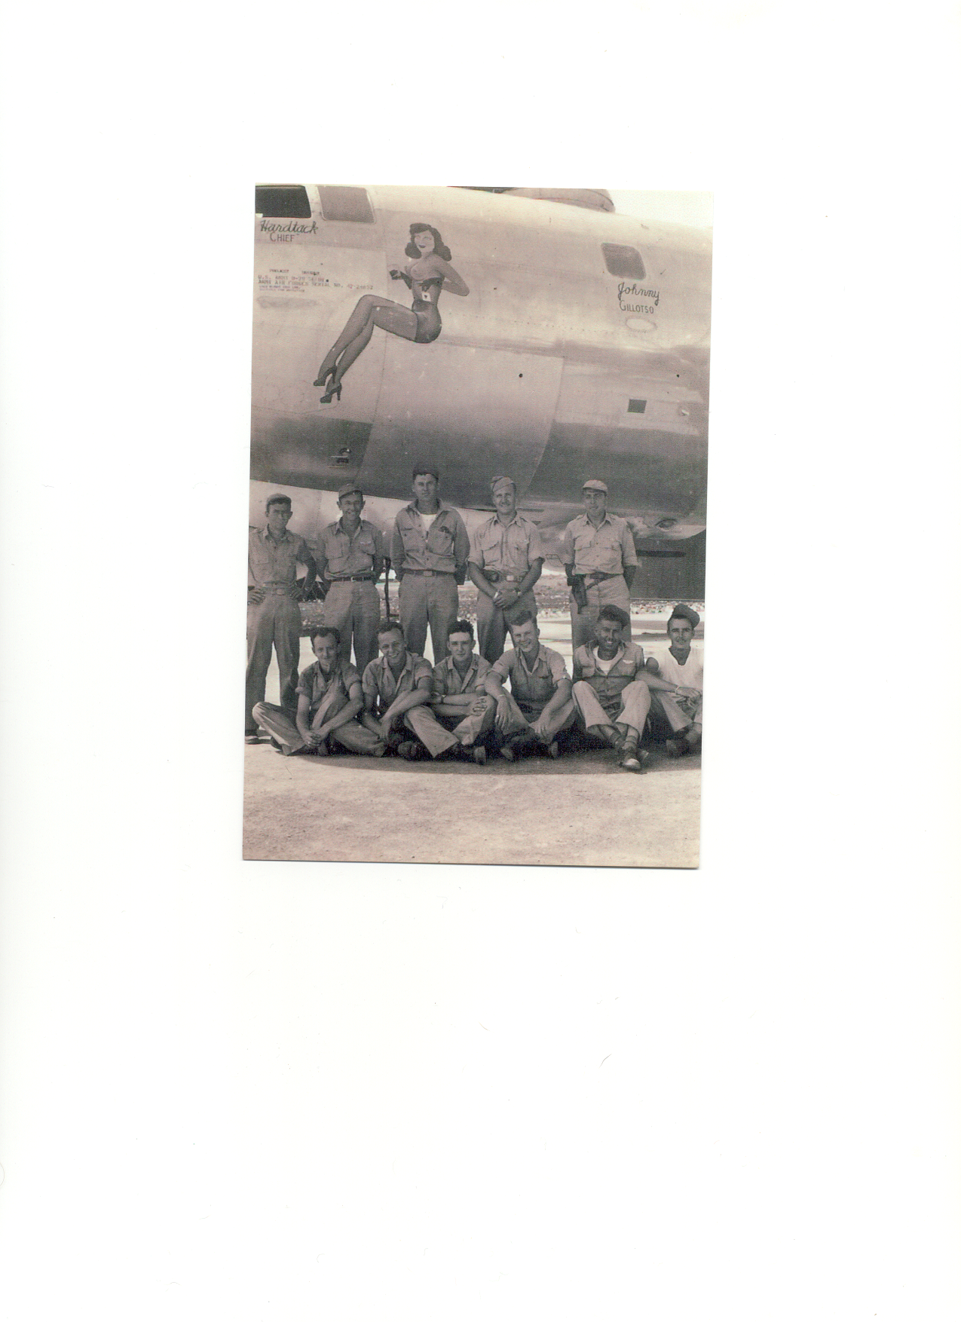
Good Deal Crew (Dad – bottom row second from the right)

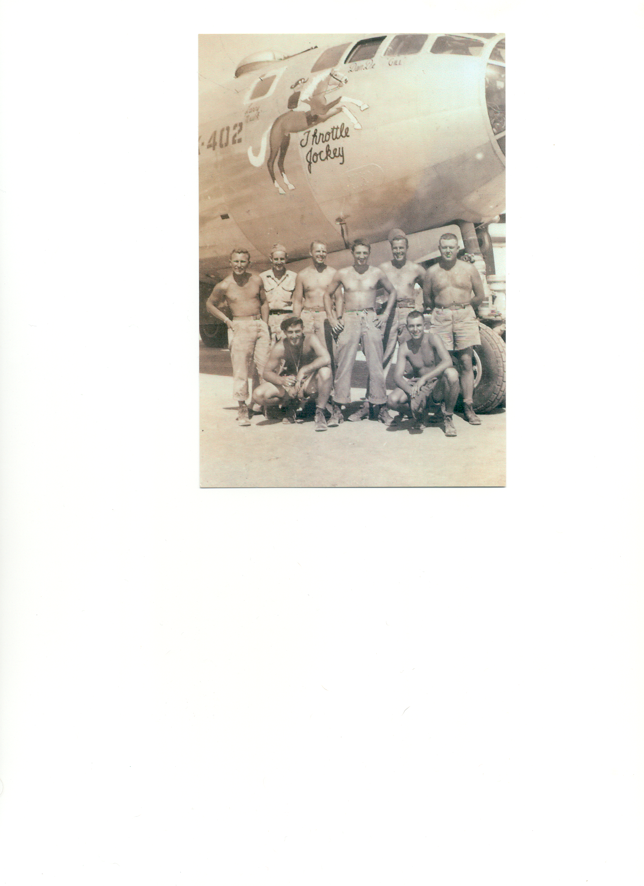
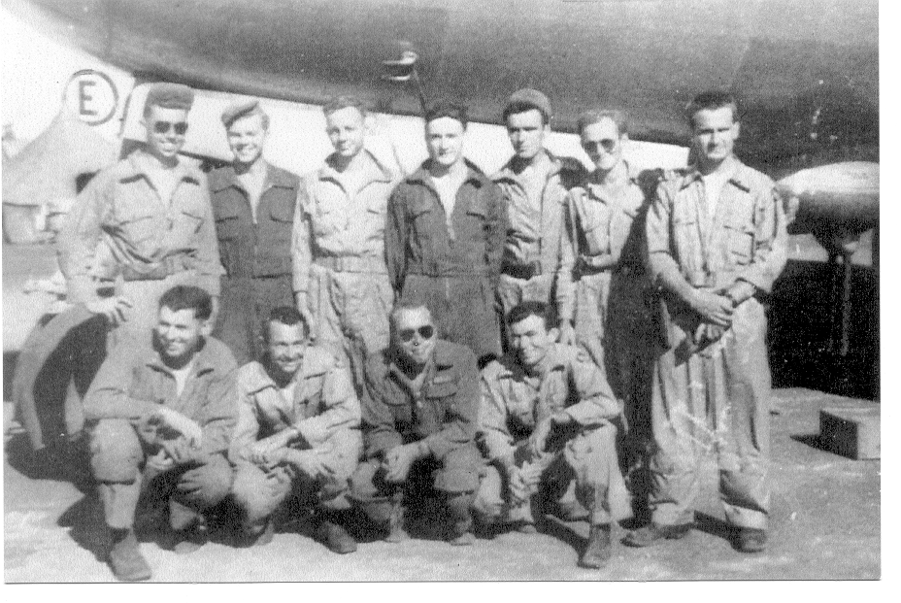
Trottle Jockey was the Ground Crew’s Side of Good Deal (Dad not in this picture – ground crew only)
Good Deal Crew (Back Row L to R) Dad; Tobin-Gunner; Blankner-Radar; Smith-Radio; Wilcox-Gunner; Willimas-Gunner; Dewitt-Copilot; (Front Row L to R) Stokes-Engineer; Hardison-Pilot; Jacobs-Bombardier; Martin-Navigator

